S3-TASKS

1. Create s3 bucket and upload some objects to s3.  
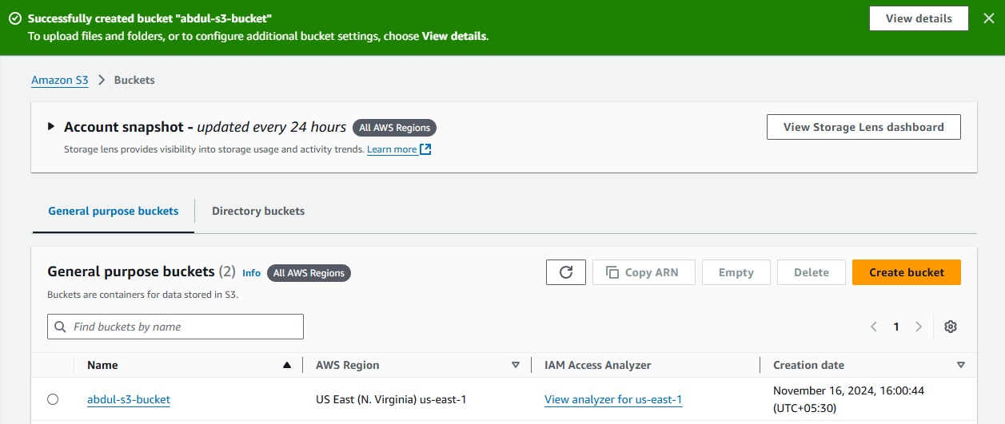

Uploaded one object  
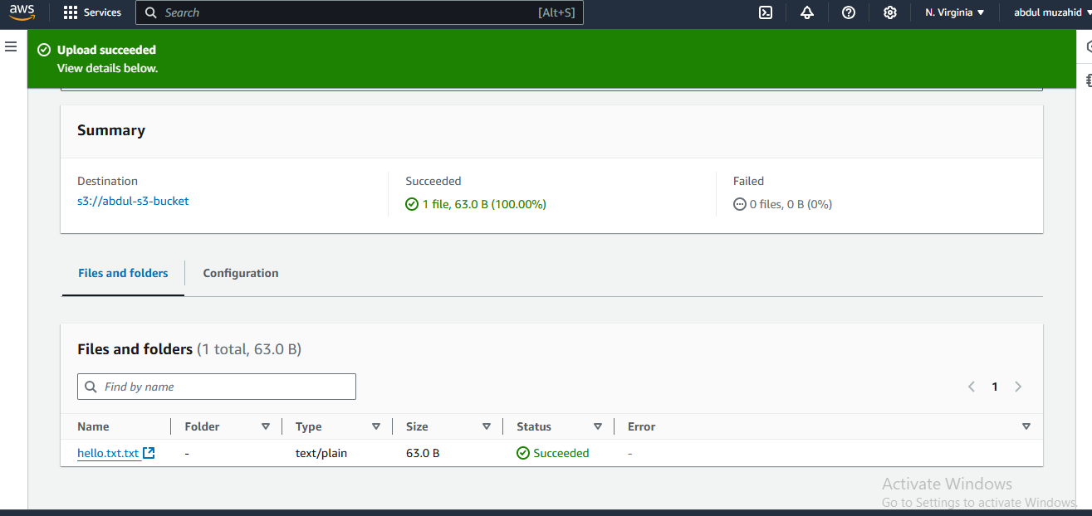

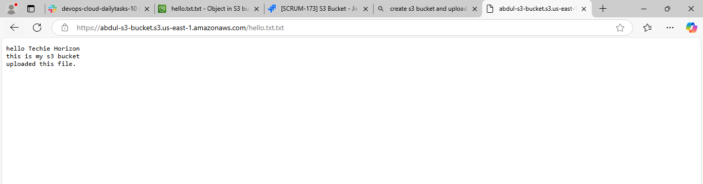

2) Deploy static website in s3 bucket.  
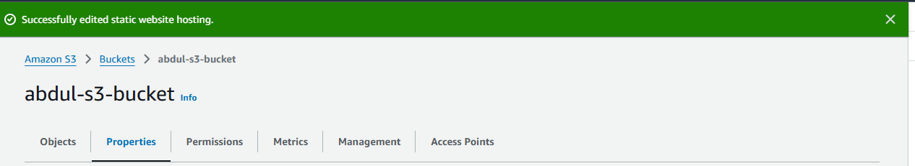

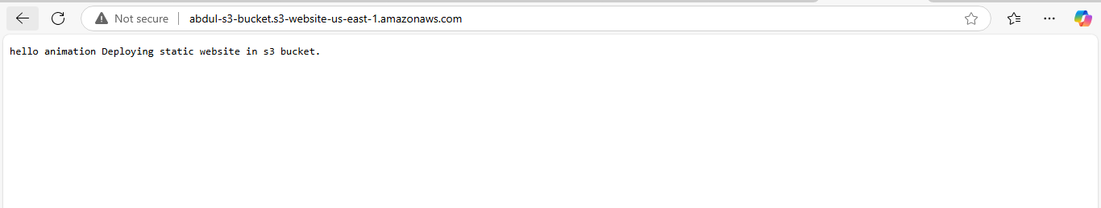

3) Enable cross region replication on s3 buckets.  
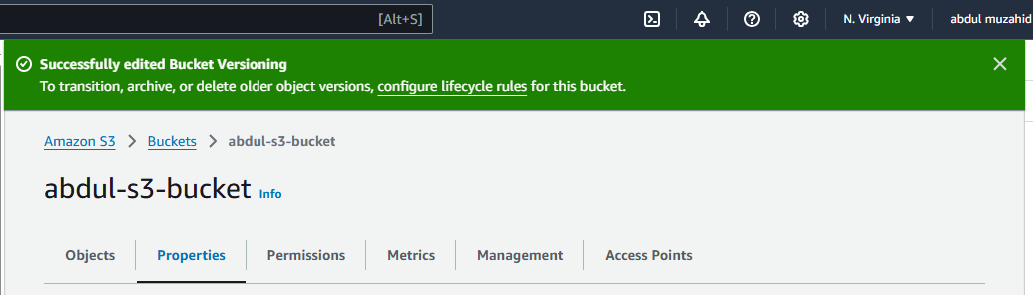

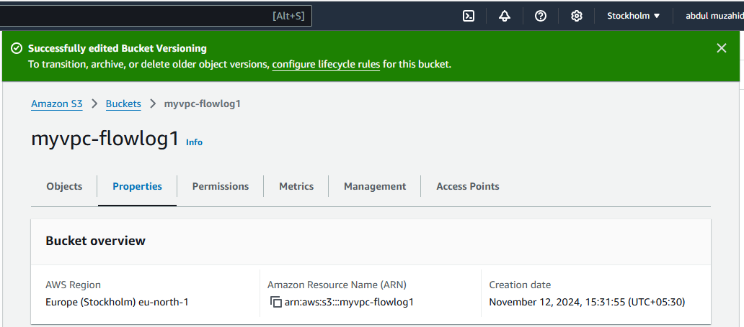

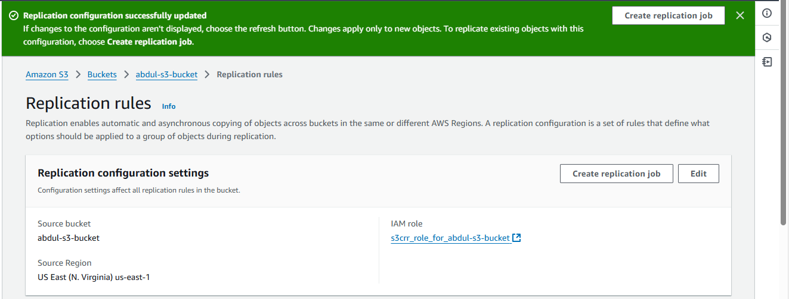  
I uploaded a file in other region and that file I can able to see in this region  
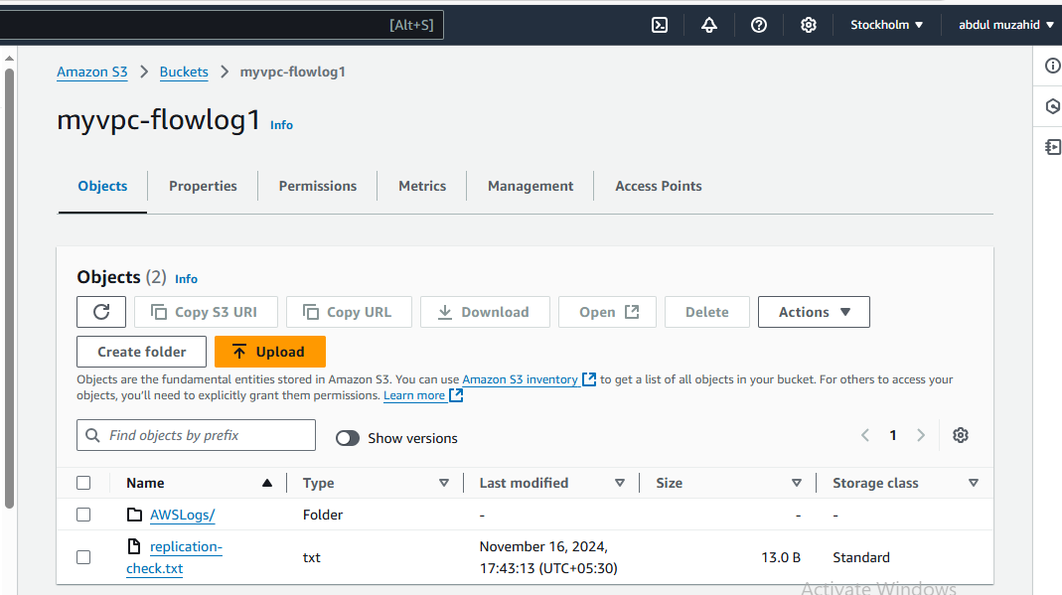

4) Configure bucket policy, only Admin user can see the objects of s3 bucket.

6. Push some objects in s3 using AWS CLI.

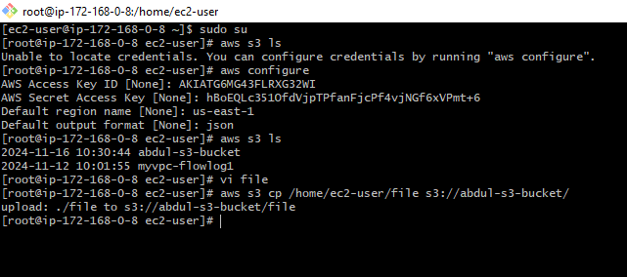

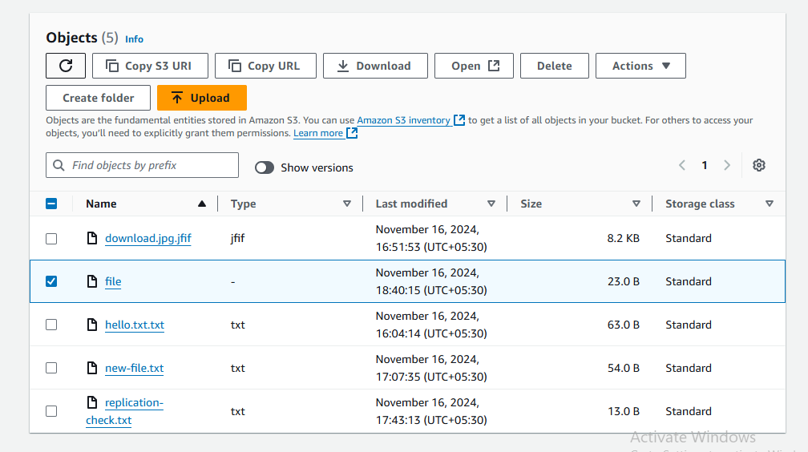

8) Upload one 1 gb of file to s3 using cli.  
